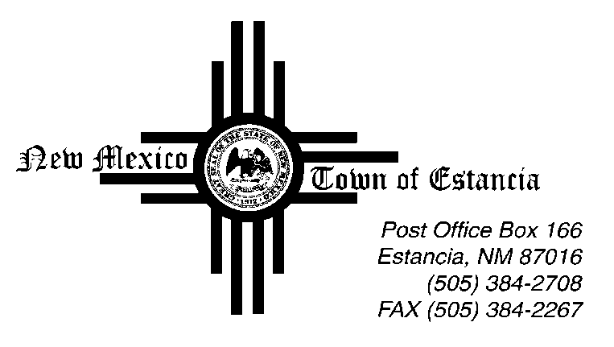

Mayor
Nathan Dial

Mayor Pro Tem
Noah Sedillo

Trustees
Morrow Hall
Stella Chavez
Albert Lovato

____________________________________________________________________________________________

Notice of Possible Quorum

04.27.2023

This Public Notice is being posted to inform the public that there will be a Possible Quorum of Town of Estancia Trustees on Thursday, April 27, 2023 at the Moriarty Civic Center.

The Possible Quorum will be strictly for the purpose of attending the Annual EMW Gas Association Meeting. No action will be taken, and no further business will be conducted.

